# Problem Statement

Determination of FSS dimensions to obtain transmission properties as per user determined cut-off frequencies.

# Objective

The objective of this project is to make it easy to fabricate the FSS for the microwave absorptive and trans missive application. As the objective is not an easy one and demands for the requirement of heavy mathematical analysis of the electromagnetic theory. Hence, to meet the objective, machine learning will be considered as the helping tool. Hence the objective modifies as, “**the calculation of various FSS parameters for the required transmission band with the help of Machine Learning**”.

# Basic understanding

The EM waves which are used as signal careers for the communication between certain devices needs to be steered as per the application and specification by the user. For these requirements to meet, one shall be aware that the EM wave must be tailored accordingly while these are passing along the channel. FSS: Frequency Selective Surfaces, acts as spatial filters for the electromagnetic waves passing through these. These FSS structures are very complex to find their optimized vales corresponding to the frequency of the careers.

## Frequency Selective Surfaces

FSS are carefully tailored, periodically arranged metallic patches which can be freestanding or over some specific substrate. These metallic patches acts as inductors and capacitors, as a result of acceleration, deceleration and accumulation of free electrons in these. The combination of inductance and capacitance results in the LC filter for the incident EM wave. The characteristic of this filter depends on the physical parameters of the metallic patches, and in turn decides the transmission and/ or reflection characteristics of the EM waves, and hence the signal along with it. The value of L and C is sophistically dependent on the dimensions of the patches as well as their orientation with respect to incident EM waves. Here the calculation of the metallic patches based on required transmission bandwidth is quite tedious job.

* Mechanism of FSS

Interaction of incident EM wave with free electrons in the metallic patches lead to motion of electrons in the direction depending on polarization of the incident wave. This motion of free electrons makes the metallic patch to act as circuit elements and hence affects the frequency response of FSS. Figure 1 illustrates the concept of metallic stripes working as inductors and capacitor is supported by the concept of free electrons oscillating due to effect of electric field associated with electromagnetic wave, which is further explained below.

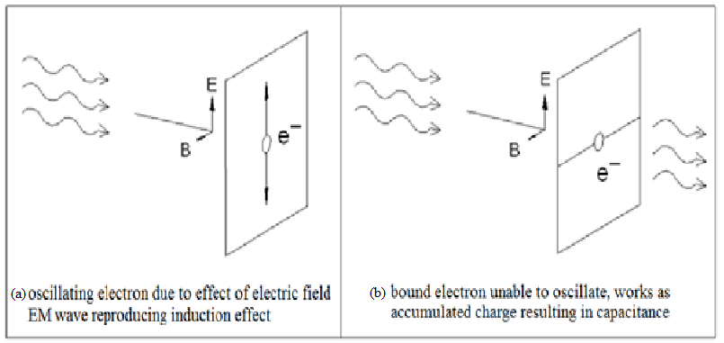

Figure 1. Effect of oscillating electron inside metallic patch as inductor and capacitor

* Equivalent Circuit Modelling

Implementing circuitry design provides us the freedom and flexibility to design and also includes loss mechanism due to induction and capacitance. Absorption can be made sensitive to a particular frequency or can also be tuned by varying inductance and capacitance of the circuit. Research in the field of materials towards their property of absorbing microwave and dependence on their characteristics is under trial. For the appropriate calculations of the impedance due to a FSS, various approximations are used. To analyze the properties of a FSS model, we create its equivalent circuit model and then compare its transmission characteristics with experimental results. Due to this model being scalar analytic approach, information regarding cross polarization will not be available.

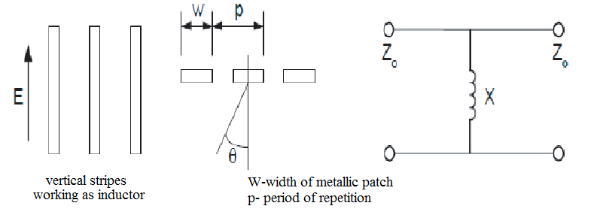

Figure 2. Equivalent circuit corresponding to parallel stripes

Figure 2 shows the working of metallic patch parallel to electric field as inductor; similarly, the patch perpendicular to electric field will work as capacitor. The equivalent circuit method includes calculation of impedance of FSS which must be comprising of resistive, inductive and capacitive equivalent of the structure.

|  |  |  |
| --- | --- | --- |
|  |  | (1) |

Equivalent circuit of three dimensional FSS can be presented by the following figure,

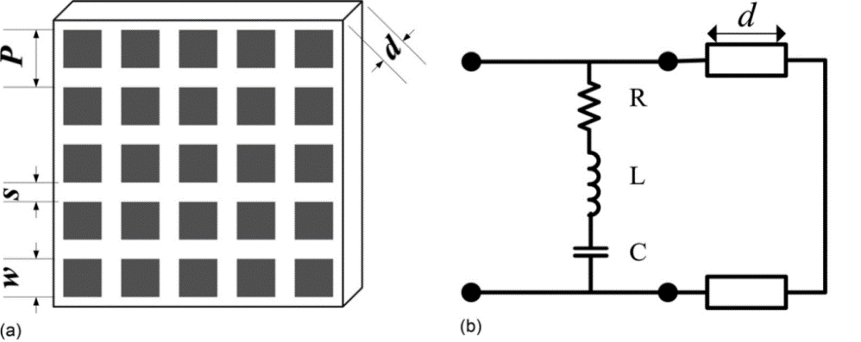

Figure 3. (a) Three dimensional structure of FSS and (b) equivalent circuit

Calculation of all the values of impedances will be dependent on the shape and size of unit cell. Here, inductance is dependent on the length of the patch parallel to incident EM wave, capacitance depends on the gap between patch, and the resistance depends on the material used for the fabrication of the FSS. ‘d’ over here is the thickness of the spacer between FSS and the remaining structure. Here the transmission line theory will be used for the calculation of impedance provided by the FSS. Total impedance of the structure will be the parallel addition of individual impedance of FSS and input impedance at the interface of FSS and the structure.

|  |  |  |
| --- | --- | --- |
|  |  | (2) |

By using the above process we can get the idea of basic structure that is required for the fabrication of FSS for a certain frequency. But this structure needs to be optimized further as in practical scenario, there are various other factors affecting the working of the FSS. For that the simulation is required. Going for simulation directly can be very long and tedious job and will be a result of various guess values to be simulated with a possibility of not even reaching the solution ever. While just calculation without simulation does not assure us of correct result. Hence we need to follow both methods, one after other.

To minimize the calculative approach for all the possibly required applications in various frequencies, we are here trying for the help of Machin Learning as the major tool to be used for the calculation of initial value to get started with.

## Dataset:

In this case we shall be using the training of the machine followed by its validation. Hence, to get started with this part, we have taken three different structures, and then used parametric analysis to create a data-set of nearly 1800 datasets for the three structures, nearly 600 datasets corresponding to each structure.

# Challenges and Approach to meet the objective

Step 1: We have selected three different structures for the FSS designs

Design 1: Can be related with figure 3, periodicity and patch sizes are given.

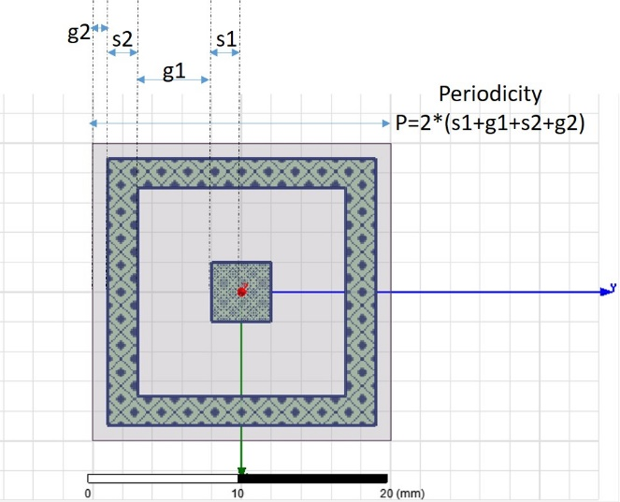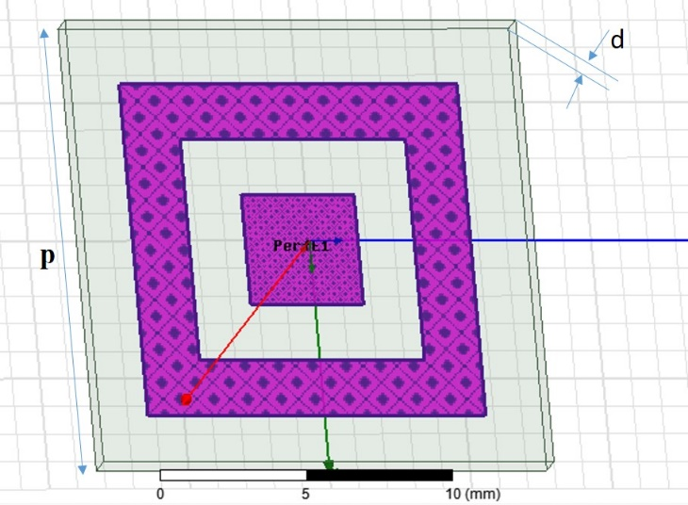

Figure 4. FSS 1 data saved with the name as Design1a_Para2

Test 1:

With the input dimensions as g1 = 4.7, g2 = 1.7, s1 = 3.4, s2 = 1.2 in HFSS model.

Simulating the structure in HFSS with above mentioned parameters.



S21 comes out to be from 7.29 GHz to 10.58 GHz for (-0.5 dB transmission)

Test 2:

With the input dimensions as g1 = 4.7, g2 = 1.7, s1 = 3.3, s2 = 1.1 in HFSS model.

Simulating the structure in HFSS with above mentioned parameters.



S21 comes out to be from 7.44 GHz to 10.81 GHz for (-0.5 dB transmission)

Test 3:

With the input dimensions as g1 = 2.7, g2 = 1.5, s1 = 2.7, s2 = 1.2 in HFSS model.

Simulating the structure in HFSS with above mentioned parameters.



S21 comes out to be from 9.62 GHz to 12.81 GHz for (-0.5 dB transmission)

Test 4:

MATLAB ML program:

With the input dimensions as g1 = 1.8, g2 = 1.5, s1 = 4, s2 = 1.1 in HFSS model.

Simulating the structure in HFSS with above mentioned parameters.



S21 comes out to be from 7.50 GHz to 7.34 GHz for (-0.5 dB transmission)

Test 5:

With the input dimensions as g1 = 3.3, g2 = 1.6, s1 = 3.4, s2 = 1.3in HFSS model.

Simulating the structure in HFSS with above mentioned parameters.



S21 comes out to be from 8.02 GHz to 10.83 GHz for (-0.5 dB transmission)

Test 6:

With the input dimensions as g1 = 2.6, g2 = 1.7, s1 = 4.5, s2 = 1 in HFSS model.

Simulating the structure in HFSS with above mentioned parameters.



S21 comes out to be from 6.51 GHz to 8.48 GHz for (-0.5 dB transmission)

Design 2

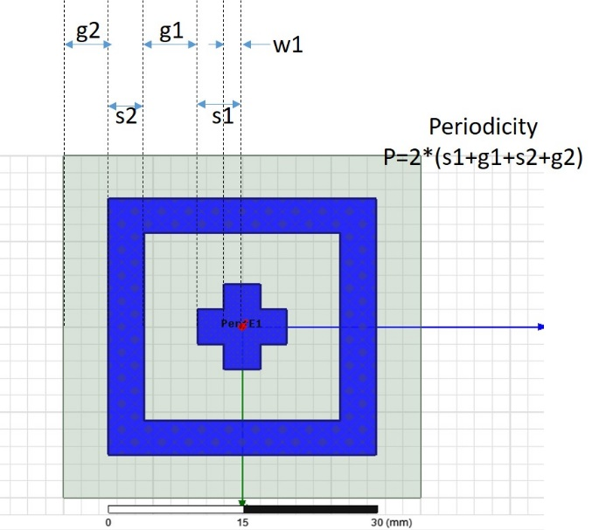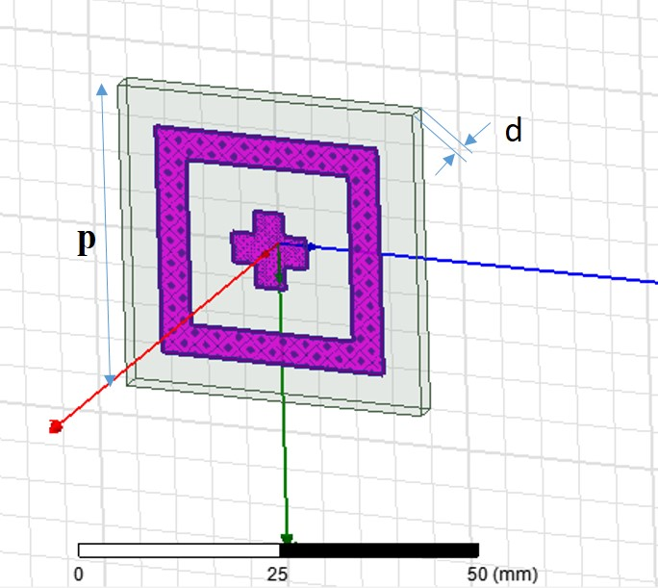

Design 3

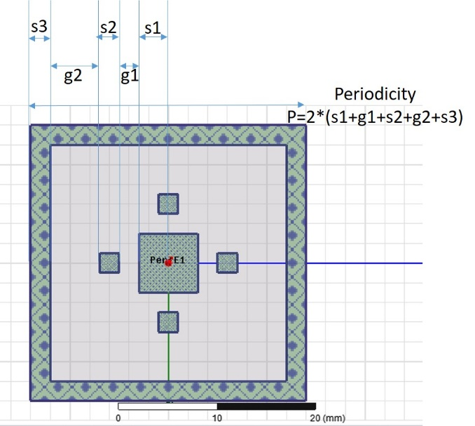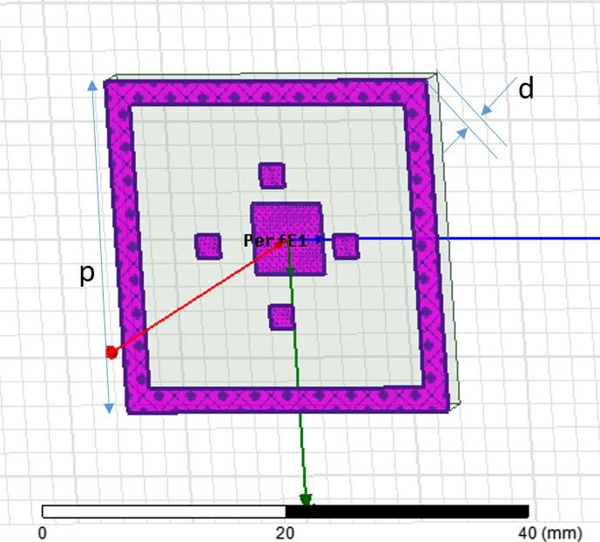

Figure 5. FSS 3, data saved with the name as Design4_Para1

Test 1:

With the input dimensions as g1 = 0.7, g2 = 3.4, s1 = 2.4, s2 = 1.4, s3 = 0.3 in HFSS model.

Simulating the structure in HFSS with above mentioned parameters.



S21 comes out to be from 7.46 GHz to 15.16 GHz for (-0.5 dB transmission)

Test 2:

With the input dimensions as g1 = 1, g2 = 4.5, s1 = 2.5, s2 = 1.4, s3 = 0.3 in HFSS model.

Simulating the structure in HFSS with above mentioned parameters.



S21 comes out to be from 6.64 GHz to 14.12 GHz for (-0.5 dB transmission)

Test 3:

With the input dimensions as g1 = 12.2741, g2 = 2.5044, s1 = 1.9466, s2 = 1.5249, s3 = 0.2158 in HFSS model.

Simulating the structure in HFSS with above mentioned parameters.



S21 comes out to be from 3.49 GHz to 8.70 GHz for (-0.5 dB transmission)

Test 4:

With the input dimensions as g1 = 0.5738, g2 = 4.3126, s1 = 2.4149, s2 = 1.3598, s3 = 0.2985 in HFSS model.

Simulating the structure in HFSS with above mentioned parameters.



S21 comes out to be from 7.08 GHz to 14.57 GHz for (-0.5 dB transmission)

Test 5:

With the input dimensions as g1 = 0.5, g2 = 6.3, s1 = 2.7, s2 = 1.3, s3 = 0.3 in HFSS model.

Simulating the structure in HFSS with above mentioned parameters.



S21 comes out to be from 5.8 GHz to 12.92 GHz for (-0.5 dB transmission)

Test 6:

With the input dimensions as g1 = 3.4, g2 = 14.1, s1 = 2.8, s2 = 1.4, s3 = 0.3in HFSS model.

Simulating the structure in HFSS with above mentioned parameters.



S21 comes out to be from 3.01 GHz to 10.31 GHz for (-0.5 dB transmission)

Step 2: The frequency range considered for the analysis has been selected from 1 GHz to 20 GHz. Transmission coefficient has been analyzed for the entire frequency range. So we have a plot of transmission coefficient with respect to frequency, for every FSS with different combination of dimension. This sums up to nearly 1800 plots of three different structures. The transmission response being in decibel, for 90 percent transmission we need to take the values in between 0 dB to -0.45 dB. So for the training of the data, we need to find the cutoff frequencies, *f*1 being the first cutoff frequency after which the transmission starts, and *f*2 being the second cutoff frequency, after which the transmission decreases.



Figure 6. Explained example of Transmission coefficient and corresponding cutoff frequencies

It can be understood from the Figure 6 that first cutoff frequency (*f*1) is 7.46 GHz and second cutoff frequency (*f*2) is 15.16 GHz. And these can be taken as the cutoff frequencies of interest as the transmission coefficient between these two frequencies is in wanted range, i.e., between -0.45 and 0 dB.

Step 3: Once we have all the sets of cutoff frequencies, corresponding to different dimensions, this will be taken as the training data for the machine. We need to train the machine with the aim to return the dimensions as the output, when it is given the cutoff frequencies by the user.

Input from user: cutoff frequency

Output from the machine: design and dimensions of the design

Step 4: Validation of the code

After the system has been trained, we can validate the results by again simulating the FSS of the dimensions provided by the system and checking if the cutoff frequencies are same as has been given by the user or not.

Step 5: The problem that will be faced after step 4 will be of having more than two cutoff frequencies along the transmission curve.

This problem will be discussed after reaching the first goal with only first two cutoff frequencies.